Nitinol Shape Memory Alloy Hold-Down Release Mechanism

Operation and Assembly Manual

Northern Arizona University Capstone
Spring-Fall 2022

Valentin Gamez
Nathan Olson
Maia Warren

Table of Contents
Table of Contents 2
Assembly and Disassembly 3
Assembly 3
Disassembly 6
Operation 6
Actuating 6
Resetting 7
Maintenance 8
Ball bearings 8
PTFE film 8
Nitinol SMA spring 8
Troubleshooting 9
Appendix 10

Assembly and Disassembly

Assembly
The Nitinol SMA HDRM was designed for assembly with minimal tools or external hardware. Many of the parts are indexed to fit in place with little to no freedom to move. Figure 1 Shows how the parts join, and this figure can be referenced also for the order in which it is assembled.

Before assembling the device, the nitinol SMA spring needs to be prepared. Crimp the positive and negative wires from the power source circuit to either end of the nitinol spring. This is done before assembly as it will be difficult to access once the device is assembled.

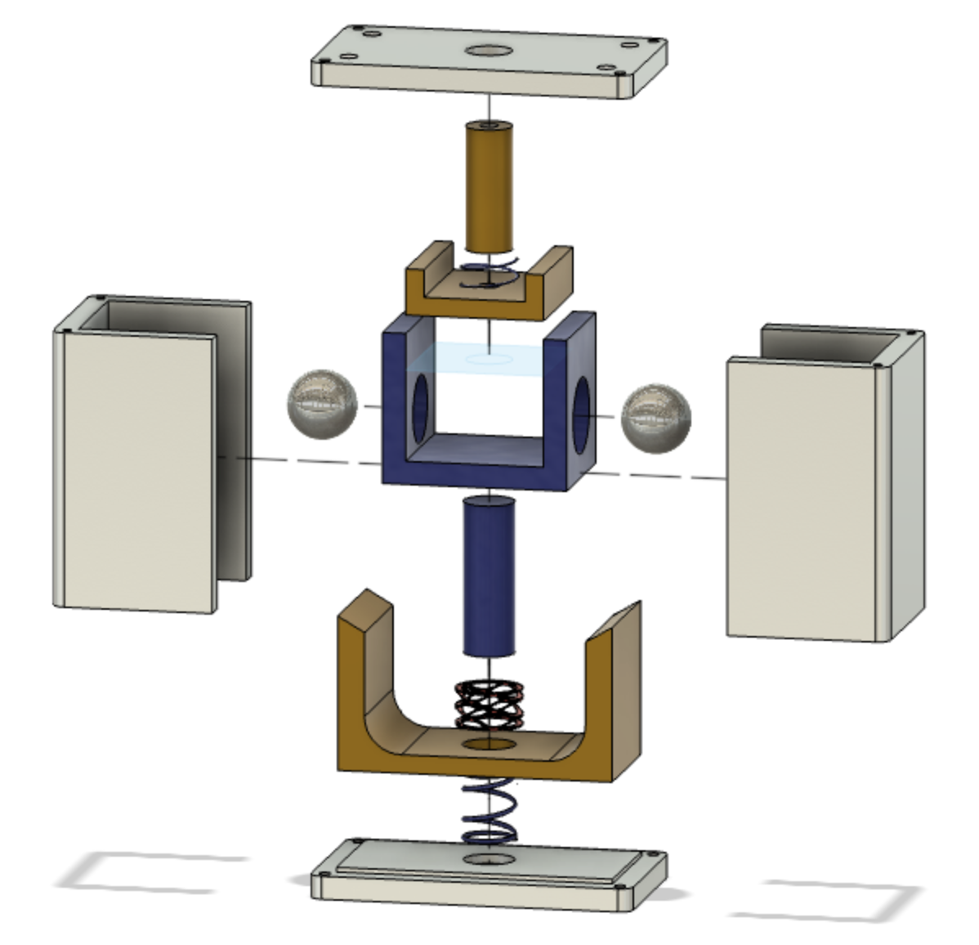
Figure 1: Exploded view for assembly
For the electrical components a pulse width modulated circuit needs to be assembled in order to protect the Nitinol spring from overheating. Figure 2 shows the electrical schematic of the PWM circuit and figures 3 and 4 show the circuit fully assembled. It is important to use a mosfet transistor that is 8 milli ohms or less to prevent the transistor from heating up instead of the Nitinol spring. The code for the Arduino can be found in appendix A and can be copied and pasted into Arduino IDE and uploaded to the Arduino.

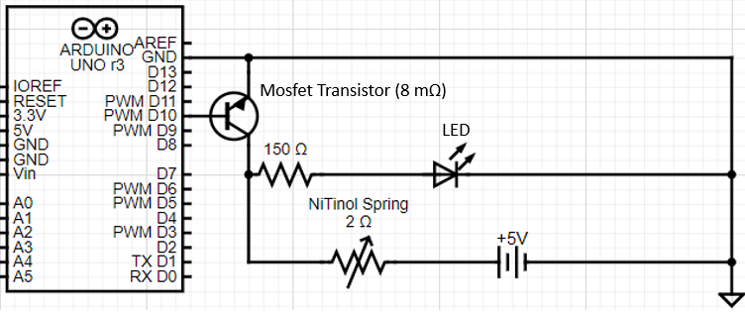
Figure 2: Electrical Schematic
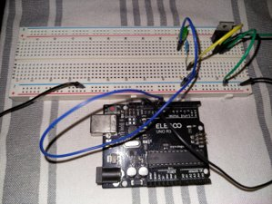
Figure 3: Assembled Circuit
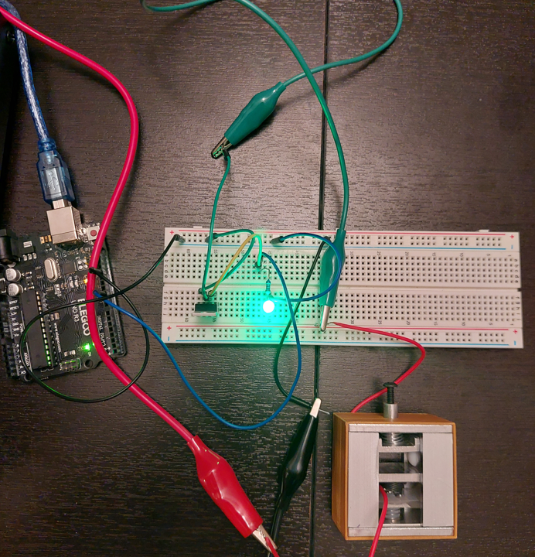
Figure 4: Assembled circuit with HDRM

Figure 5 shows the device fully assembled. In the current state, the screws on the top and bottom are omitted and replaced with a sleeve to retain the device in its assembled state. Figure 6 shows the original plans for assembly, with the only difference being that there are four screws each on top and bottom that hold the product assembled, instead of the sleeve. When installing the screws, tighten them down snugly, but not overly tight. Depending on the manufacturing process and which iteration of the device, either of these assembly methods may be used. If the sleeve is used for assembly, ensure that the pin is in its deployed, or down position to allow the sleeve to pass over. For the screw method, pin position is not relevant.

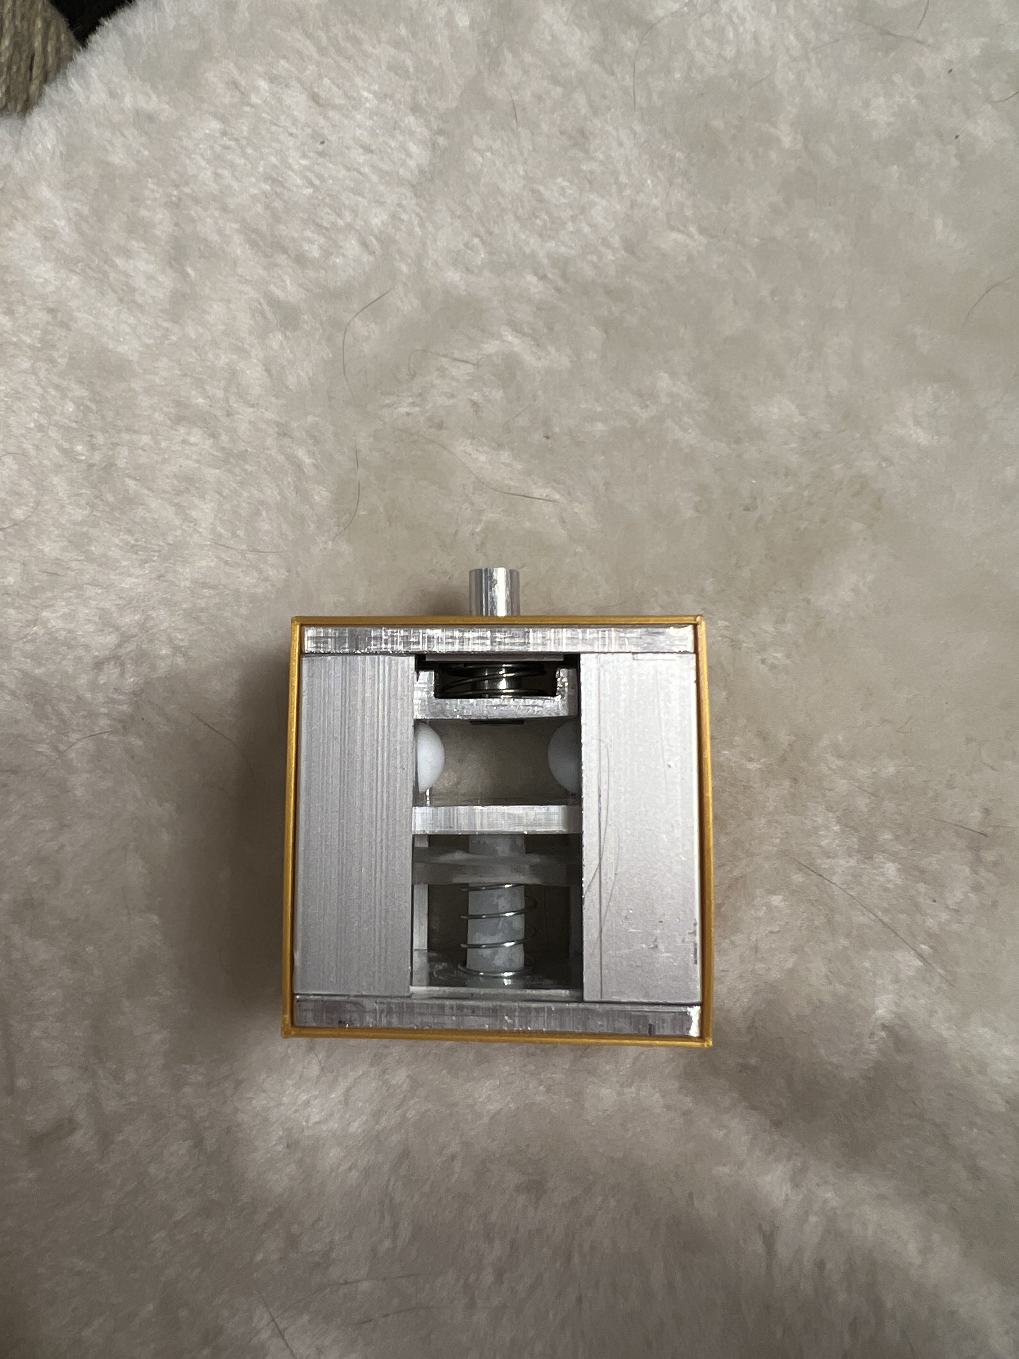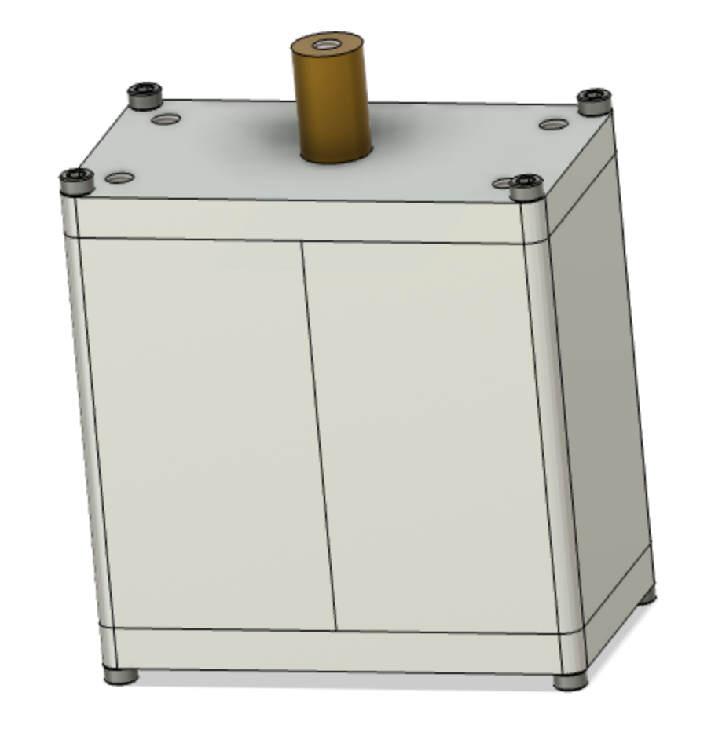
Figure 5: Assembled view with sleeve for retention. Figure 6: Assembled view with screws for retention

Once the device is assembled, ensure that it is connected to the power circuit and the power circuit is connected to the power source.

Disassembly
The disassembly process is straightforward; if your product is using the sleeve retention method, make sure the pin is down before attempting to slide off the sleeve. Once the sleeve is removed, the rest of the assembly will come apart. If your product is using the screw retention method, the position of the pin does not matter. Simply unscrew all eight screws holding the device together and the rest of the assembly will come apart.

It is not necessary to remove the cable connections.

Operation

Actuating
Ensure the device is assembled fully, connected to the power source, and the pin is in its outward position. If the pin is not in its outward position, use the reset screw to thread into the pin, then pull it out; this should reset the device.

The pin should be loaded in shear, or perpendicular to the axis of the pin. This can be seen in figure 7
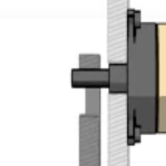
Figure 7: Load direction of the pin.

The power source needs to be set to 5V and connected to the PWM power circuit. Ensure the circuit is receiving power; the LED should be blinking. See figure 8 for a photo of the setup. Once you are ready to actuate the device, turn on the power source. The HDRM should now be receiving power. In 9-12 seconds, the device will actuate.

If the device does not actuate within 15 seconds, turn off the power. This is to preserve the life of the SMA spring and avoid burning the components it is in contact with. See the troubleshooting section if this occurs.

Resetting
Allow the device one minute to cool down, and then thread the reset screw into the top of the pin. Pull it out as far as it will go. It should stay in the extended position and the device should be reset. If the pin goes all the way back down after the reset process, see the troubleshooting section.

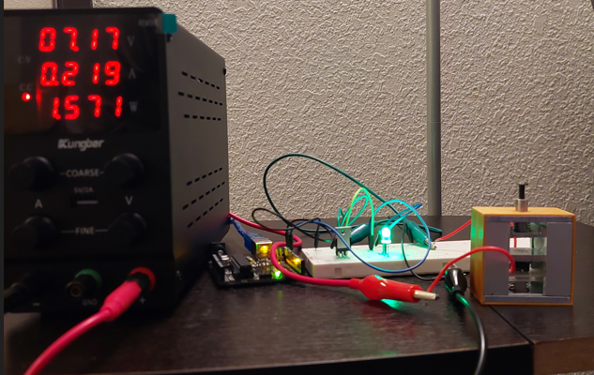
Figure 8: Power Supply (left), PWM power circuit (middle) and HDRM (right).
The HDRM should be resettable and re-deployable up to 40 times, however, for reliability, it is only recommended that it is used 20 times before replacing components or replacing the device.

Maintenance
There are some components that will receive wear over time. Due to the dynamic operation of the device, and the cyclic heat pattern when actuating it multiple times, some parts will need to be replaced if one plans to use it beyond its recommended life cycle.

Ball bearings
The ball bearings are made of PTFE for low friction. Their purpose in the device is to provide a barrier that prevents the device from actuating, and therefore experiences constant forces and stresses. It is possible that over the course of the HDRM’s life, the ball gets damaged and prevents the device from actuating reliably and smoothly.

PTFE film
The surfaces in contact with either end of the nitinol spring are exposed to high temperatures. PTFE film is lining those surfaces to act as a heat shield protecting the other internal parts. If the device is powered too long, the temperature increases and damage the film, causing potential for future failure. This film is a 0.005” layer and may need to be replaced if the user suspects that it has been damaged.

Nitinol SMA spring
The Nitinol SMA spring experiences cyclic heating and cooling as the device is reset and reused. Each cycle lowers the life of the spring as the material fatigues. The current design allows for 20 cycles comfortably, and up to 40 cycles before failure. If the owner wishes to use the device beyond its useable life, they will likely need to replace the nitinol SMA spring and re-crimp the electrical connections to the end of the spring.

Troubleshooting
The following table outlines some potential issues and references potential fixes in the list below. Another option is a full disassembly and re-assembly with part inspection.

Table 1: Troubleshooting Plan
Issue | Troubleshoot
- Device will not actuate | - Ensure power source is on  - Ensure power circuit is operational  - Test with no load; decrease load  - Ensure lower lock moves down properly, if not, check for issue 5  - Check for issue 3
- Device will not reset | - Ensure the SMA spring is contracted fully, if yes, Check for issue 4
- Lower Lock moves down, pin does not retract | - Make sure ball bearings are not damaged and can move freely  - Make sure there is no binding or unwanted friction in the moving pin piece.  - Make sure top spring is intact
- Lower lock will not move up | - Make sure bias spring is intact  - Make sure ball bearings are not damaged and move freely  - Check for unwanted friction or out-of place parts in assembly.
- Lower lock will not move down when actuating | - May need to replace Nitinol spring  - Make sure Nitinol spring is receiving power, if not check issue 6.  - Check for binding or anything preventing motion.
- Nitinol spring is not receiving power | - Check crimps to nitinol spring  - Check that PWM circuit is receiving power  - Check that power source is on.  - Ensure proper cable management and look for loose connections  - Check power supply interface to ensure current and power is fluctuating, if not follow next bullet point  - Ensure wires are properly connected to Nitinol spring. If soldered onto Nitinol, the outer layer of the Nitinol must be removed for proper connection through chemical flux or scraping off.

Appendix

Appendix A: Arduino Code

const int transistor = 10;

void setup()
{
pinMode (transistor, OUTPUT);
}

void loop()
{
digitalWrite (transistor, HIGH);
delay(1000);
digitalWrite (transistor, LOW);
delay(1000);
}

